Mitosis
Mitosis is a type of cell division whose purpose is to produce two new cells that are genetically identical (to each other and to the parent cell) for the GROWTH of the organism AND REPAIR of tissues and REPLACE worn-out or damaged cells
It produces two new daughter cells that are genetically identical to each other - so that they can continue to carry out essential life processes. (so each new cell has the same number of chromosomes and genetic content) f
The Daughter cells are diploid (have the normal number / two of each chromosomes)
Mitosis occurs in all somatic cells (body cells)- where ever more cells are needed

Process
During mitosis the DNA is organised so that the two copies can be separated. The replicated chromosomes separate, 2 new nuclei form, cell splits in two. sciPad Pg 69 & 70

Mitosis occurs at a higher rate in areas where most growth or replacement of cells is occurring, such as:
- Root / Shoot tips - are the growing point for a plant - so Mitosis rapid here especially during spring OR when seedlings are young/seeds are germinating, buds, flowers are forming etc
- Hair follicles - constantly growing
- Bone marrow - constantly active in forming new red blood cells to replace those damaged or worn out from transporting Oxygen around the body (replaced after approx 100 days)
- Skin cells - are constantly active in forming new cells to replace the daily loss from the epidermis
- Mucous membranes etc.
Mitosis rates increase in areas of cellular repair, the site of damage and in Cancer cells.

Cells that divide less often include Liver cells and Neurones.

Factors that Affect Mitosis

Stages in life and growth & repair

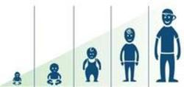
After an injury many cells are replaced in order to repair the damage. The rate of mitosis must increase in order to produce these new cells.
Similarly the rate of mitosis also increases during periods of growth, such as our development in the womb – zygote to embryo - childhood and puberty.

Nutrient availability
Nutrients are needed as a source of energy and as building blocks. Cells will need DNA nucleotides in order to synthesise new DNA and the cell organelles will have to be copied too. A lack of necessary nutrients can restrict or stop mitosis.This is why people in areas of famine are often smaller and shorter.

Cell Type & Location

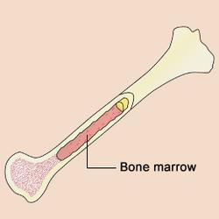
Body tissues that are replaced frequently have a higher rate of mitosis. For example bone marrow which is responsible for blood cell production is an area in the body where rapid mitosis occurs. Skin cells, hair follicles and the cells lining our intestines (epithelial cells) all have high rates of mitosis as these tissues constantly need to be replaced.

Enzyme Activity
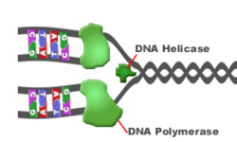
DNA replication, mitosis and cell division are controlled by an array of proteins and enzymes. Therefore the factors that affect enzymes can also affect mitosis. Some of the key factors that affect enzyme activity include:
• Temperature
• pH
• Substrate concentration (e.g. the availability of nutrient building blocks)
• Enzyme Cofactors (some dietary vitamins are essential for enzyme function)
For further details see ENZYMES ACTIVITY -FACTORS

Factors that can slow down the Rate of Mitosis:
- Temperature, pH ie: factors that affect Enzyme action !
- Presence of mutagens such as alcohol or radiation and or carcinogens
- Availability of raw materials in the cell such as Phosphorous (which is needed for DNA Replication)

